**PROJECT 1**

* A windows instance created using AMI: Windows 2012 R2 base:

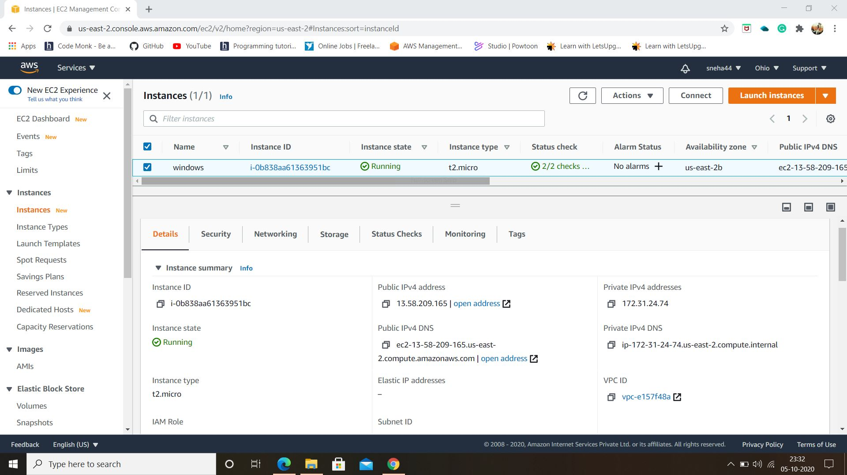

* Connection can be established after 2/2 status check done.
* Windows instance is launched using RDP. Installation of IIS web server using Powershell ISE can be done by Remote Desktop Connection.

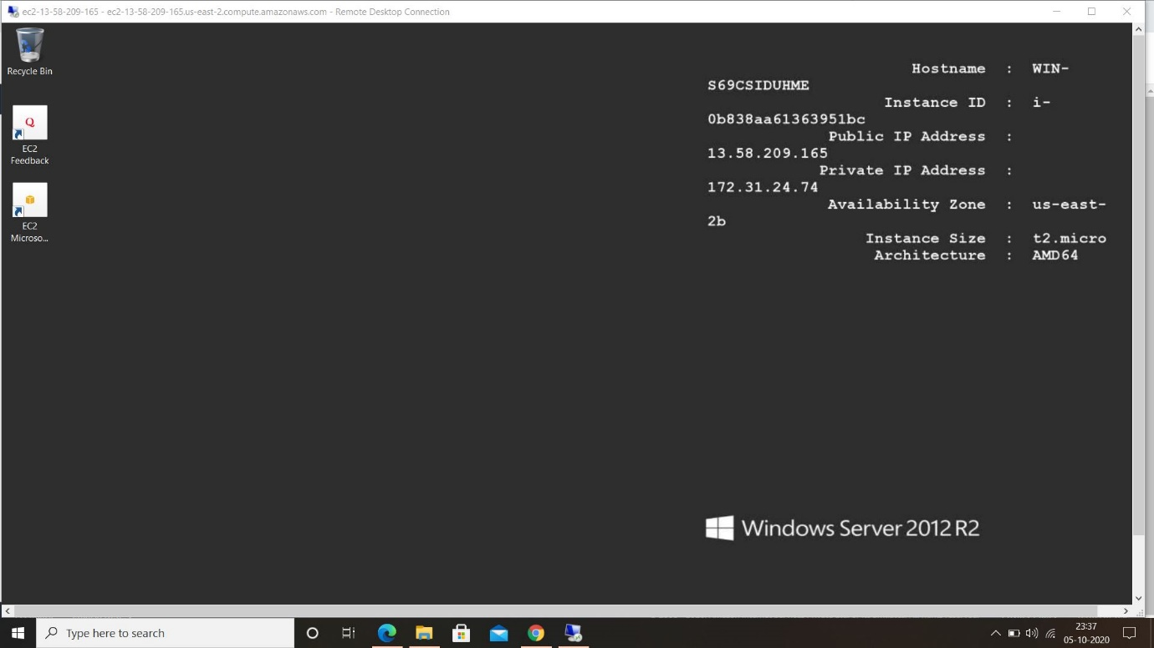

* After the installation of IIS server to check whether installation is succesful or not, we open the public IPv4 address .

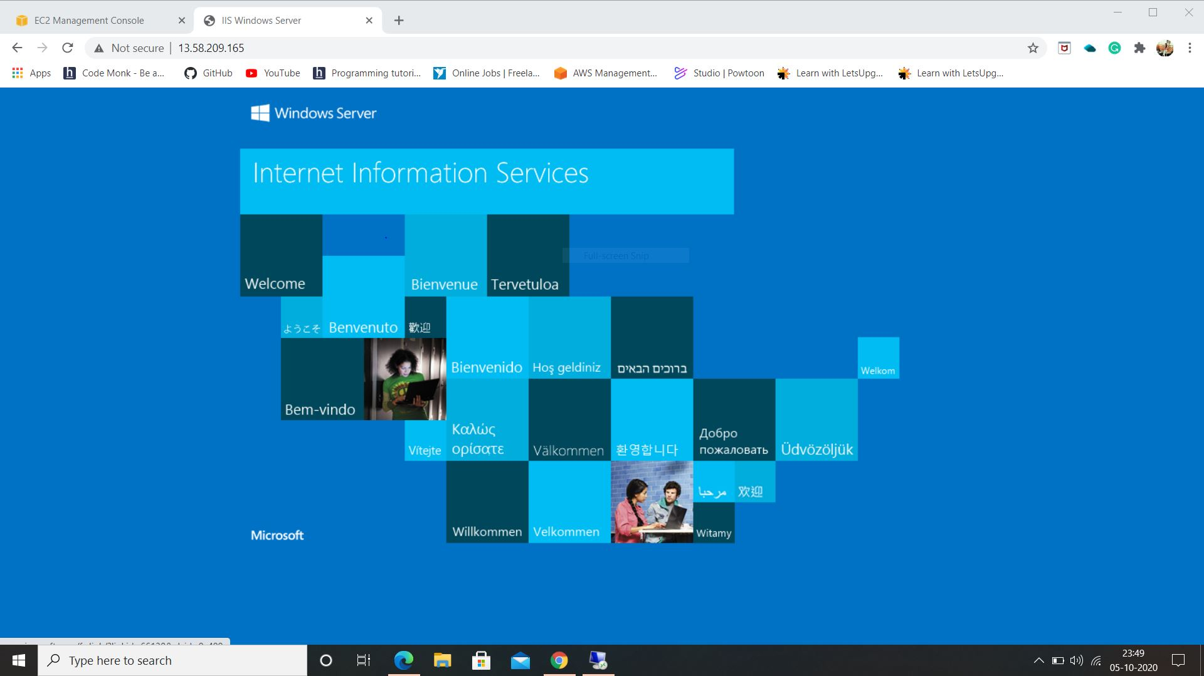

* Once the IPv4 address open successively, we terminate the instance. As soon as the state of instance changes to shutting-down or terminated no incurring charges are applied for particular instance.
* If you stop a running instance, the instance performs normal shutdown and stops running here we charge minimum when the stopped instance is restarted.

**----xx----**

**PROJECT 2**

* A windows instance created using AMI: Ubuntu Server 18.04 LTS (HVM):-

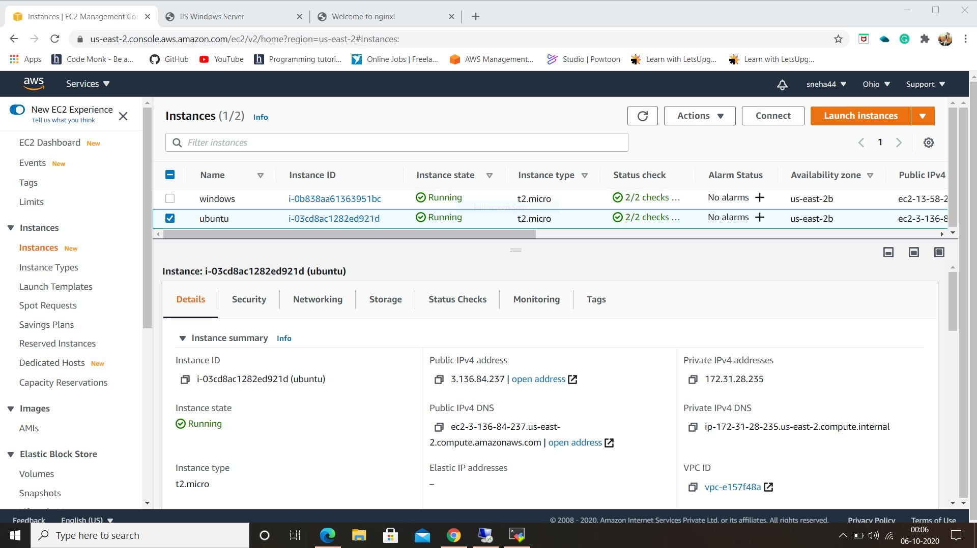

* Here, we install Nginx web server using bash on MobaXterm Portable Edition.
* To check whether Nginx is installed successively, now open the IPv4 address where we can see the below web page.

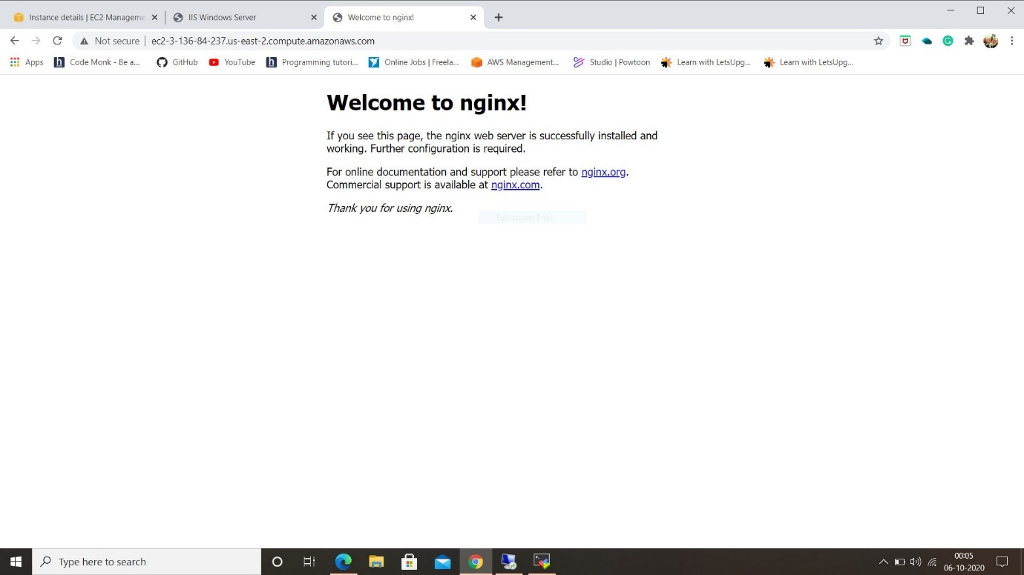

* If stopped, the instance is shut down and cannot be used. The instance can be restarted anytime.
* If terminated, the instance has been deleted permanently and cannot be started.

**----xx----**

**PROJECT 3**

* A windows instance is created:-

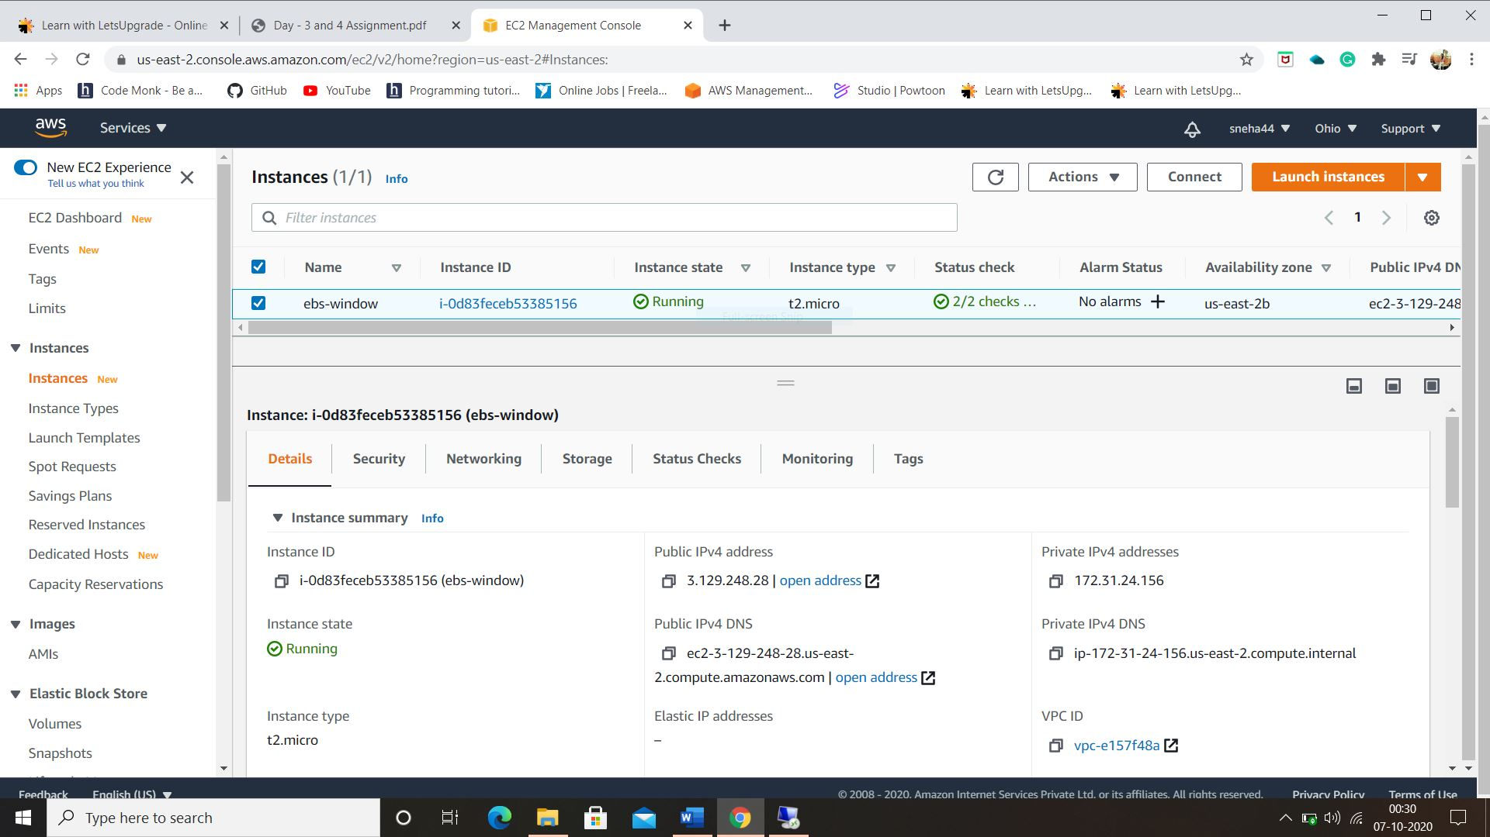

* Elastic volume, a feature of Amazon EBS that allow you to dynamically increase capacity, better performance.
* Three storage Volumes are created where volume1 is a root storage.
* Status of volumes are checked on Remote Desktop Connection in Server Manager section.

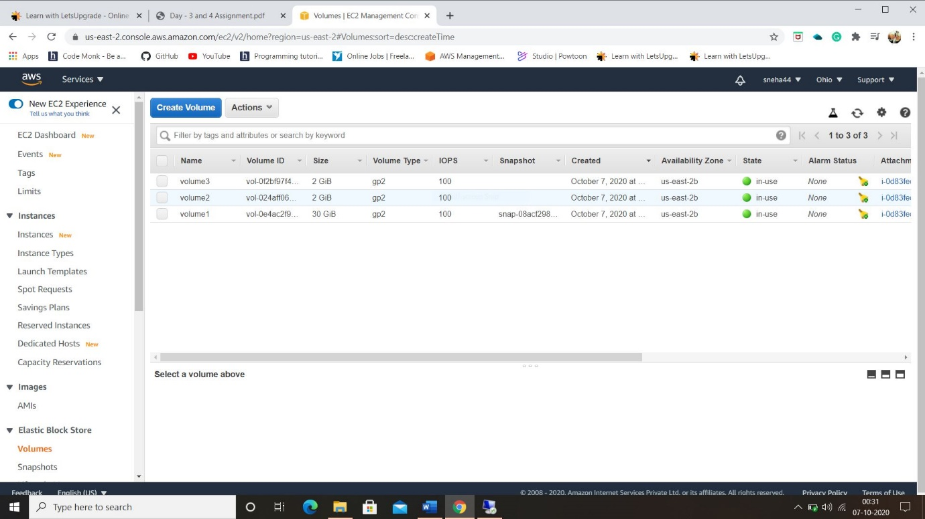

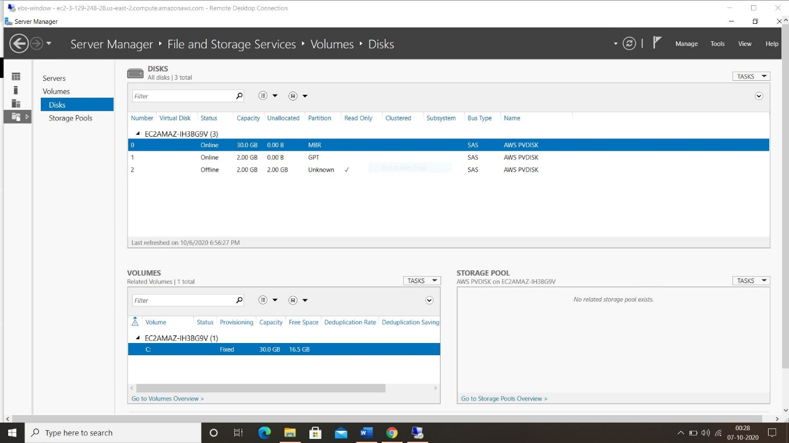

* Snapshot is created by volume1:

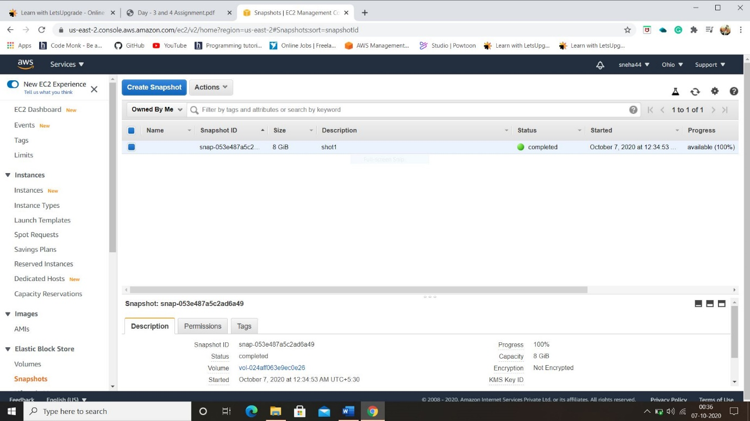

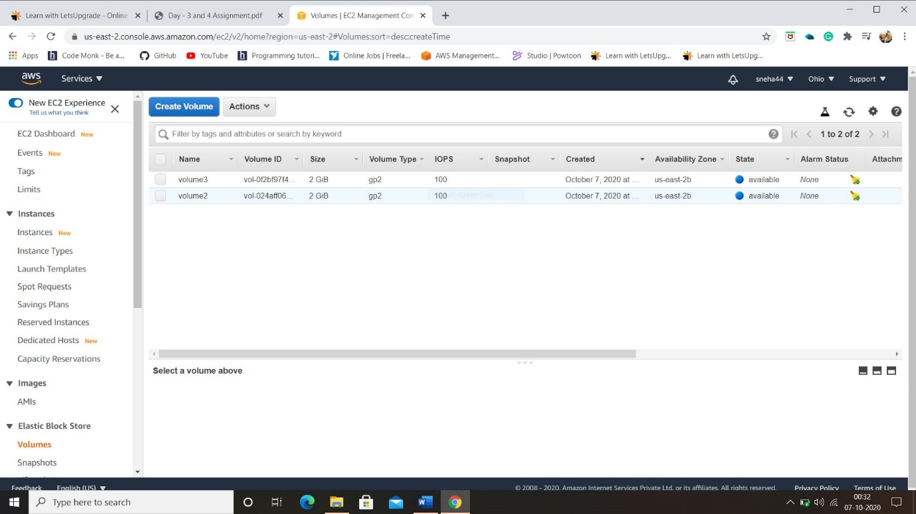

* While the instance is stopped, we can treat its root volume like any other volume and modify it only when volume is detached from the stopped instance and attached to running instance. Here, Amazon EBS get charged for the storage of volumes when used for longer time.
* When the instance terminates, the data on any instance store volumes associated with the instance is deleted and other volumes change its state from in-use to available. By default, Amazon EBS root volumes are automatically deleted.

**----xx-----**

**PROJECT 4**

* To install an Apache server:-

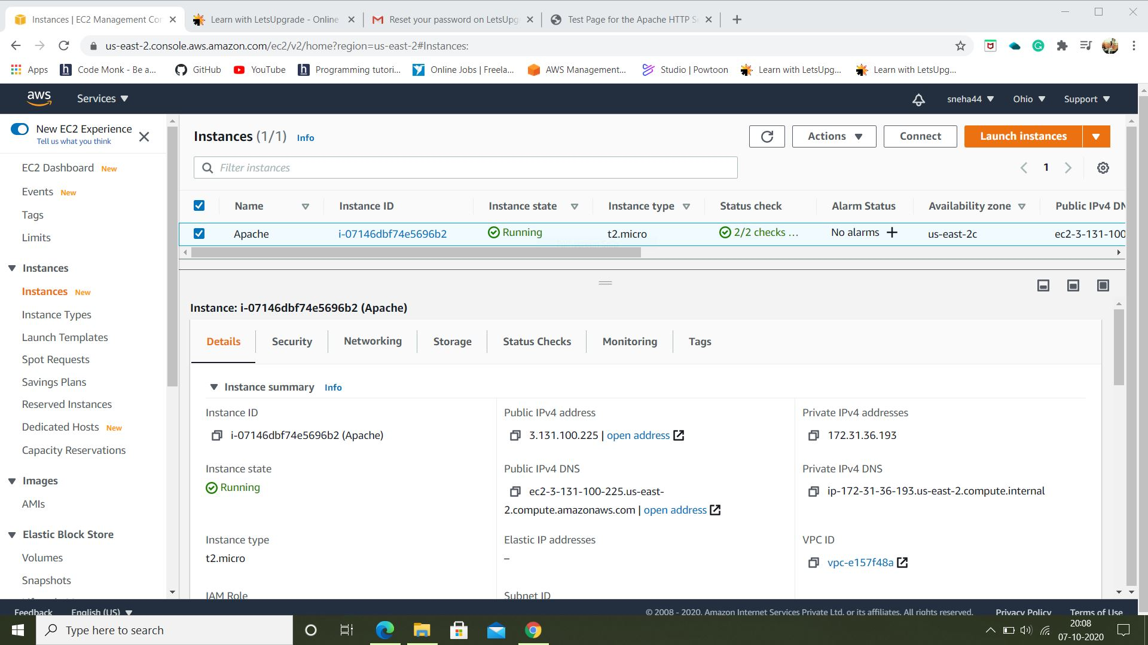

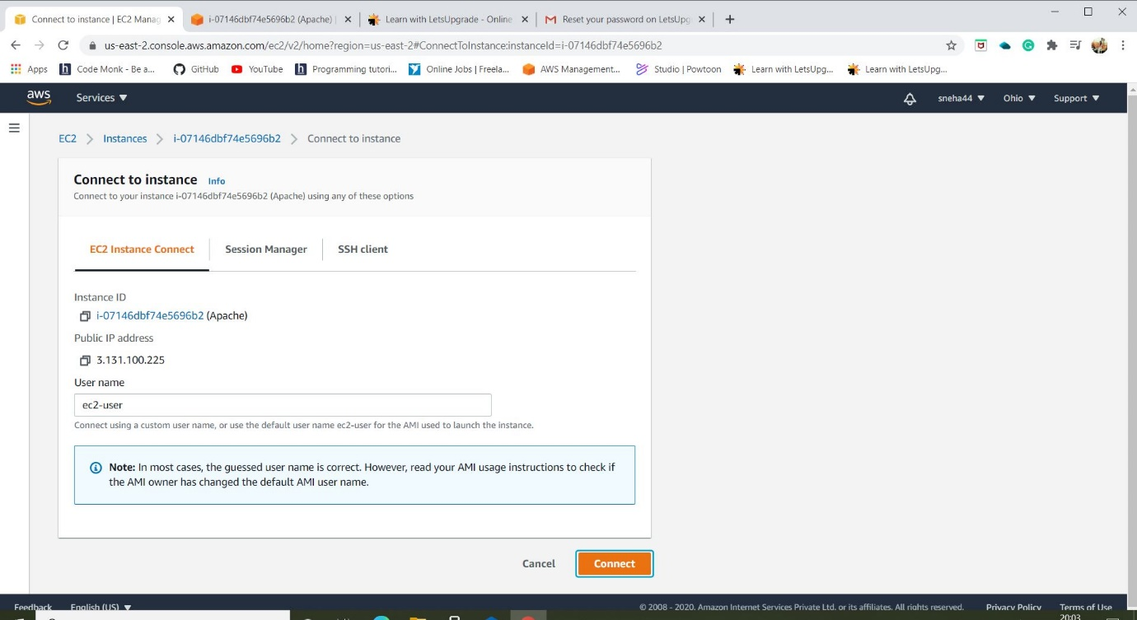

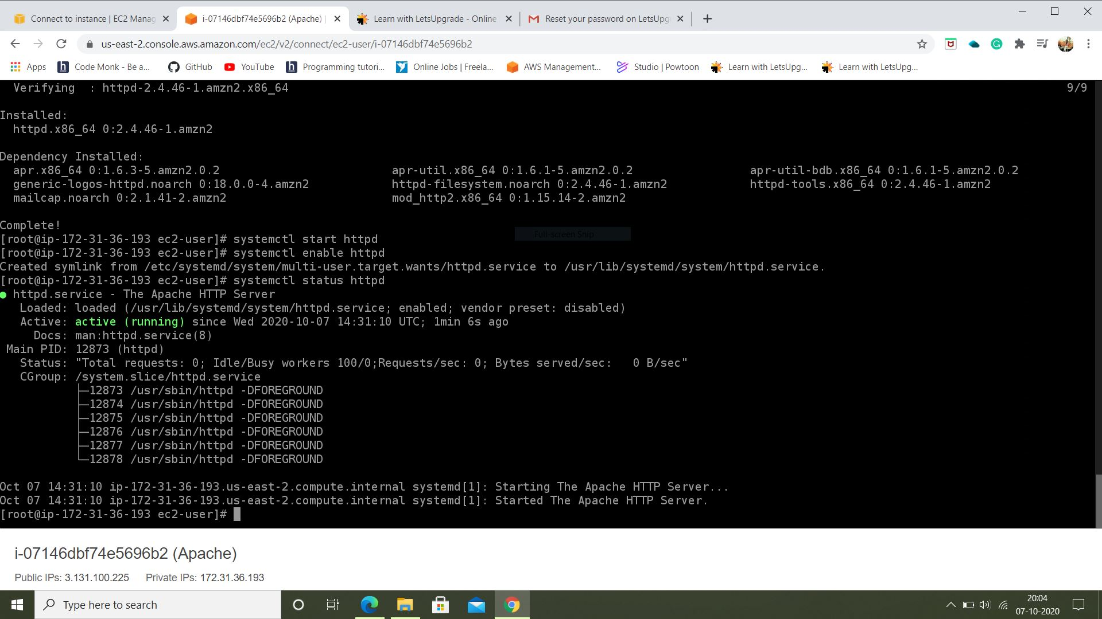

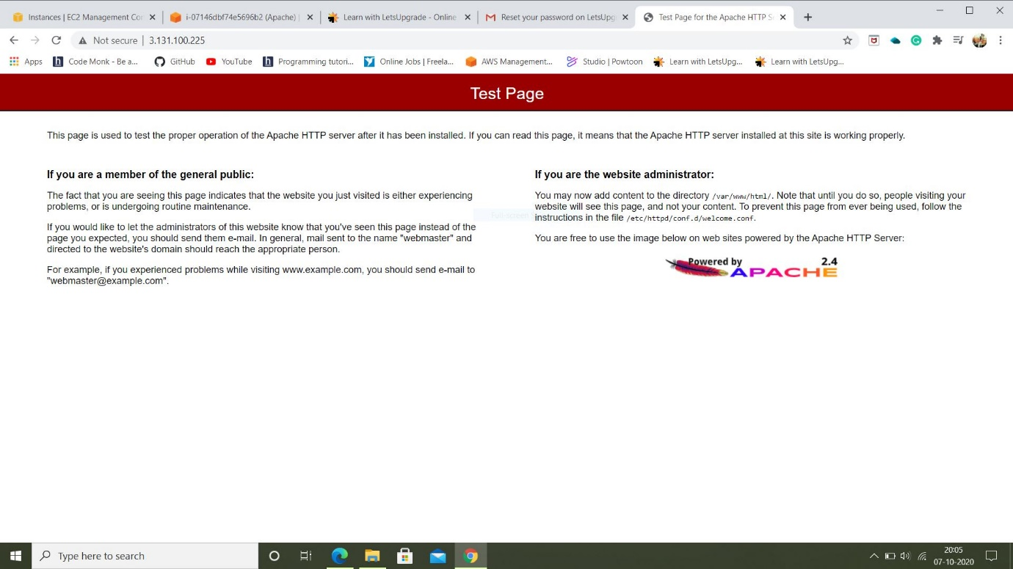

* Elastic IP address is a static IPv4 address, using this we can mask the failure of an instance or software by rapidly remapping the address to another instance in an account.
* It provides a single IP address that can associate with different EC2 instances over time.

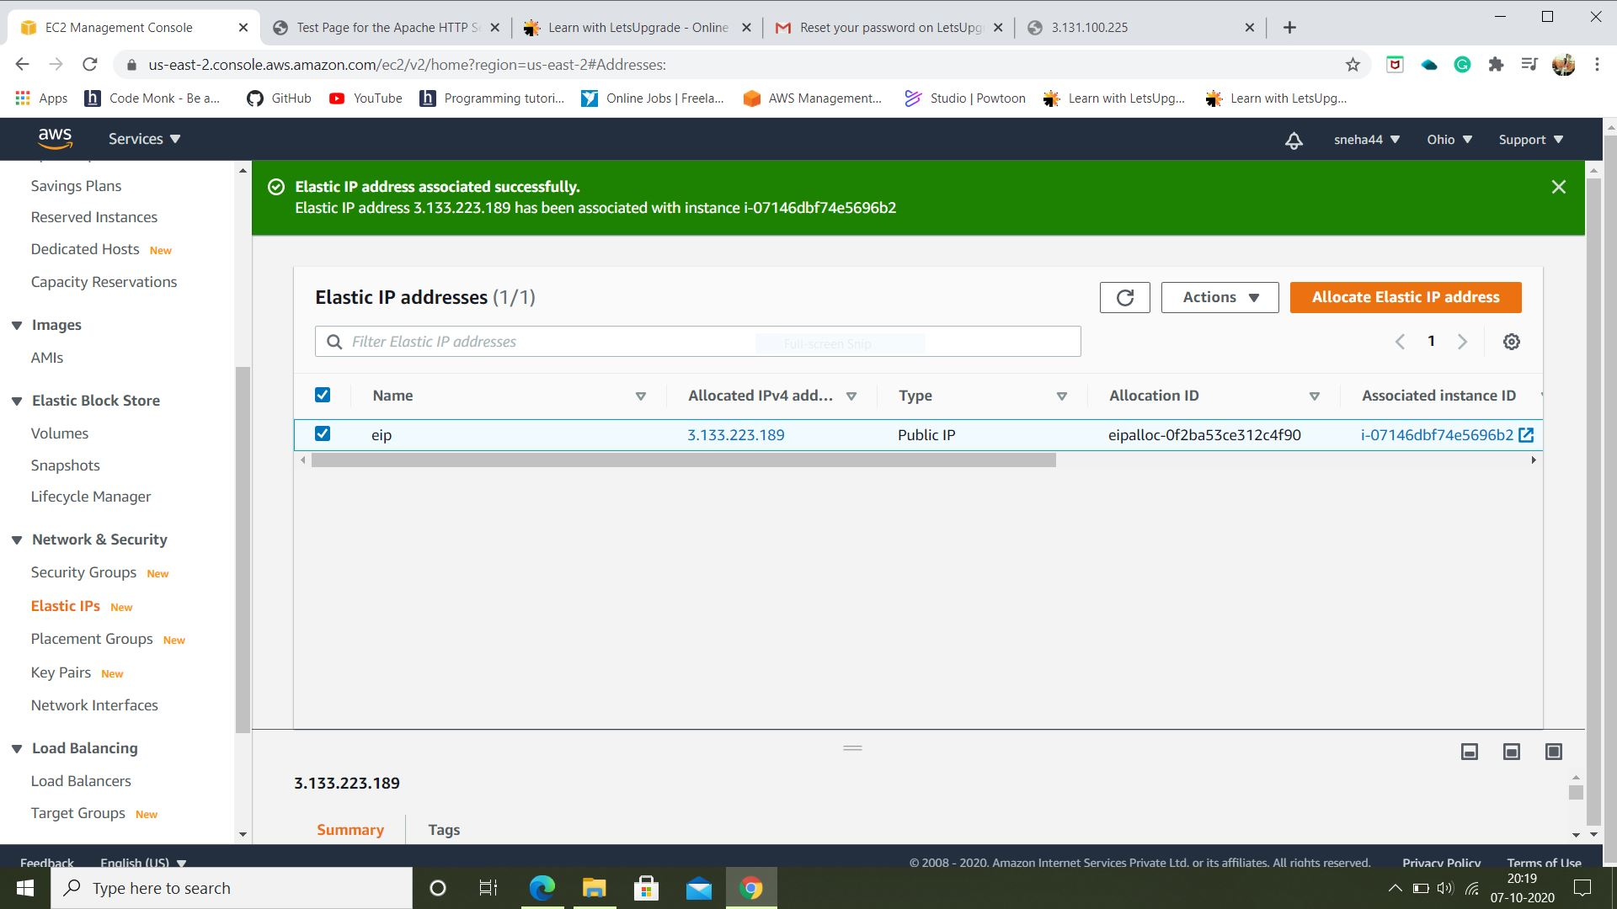

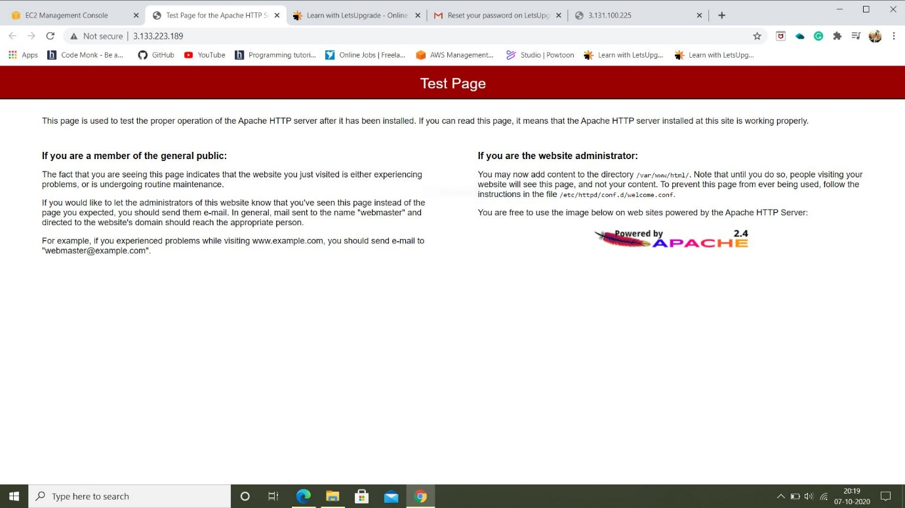

* A disassociated Elastic IP address remains allocated to the account until explicitly released.
* After releasing an Elastic IP address, it is released to the IP address pool. The address released do not remain associated with EC2 instance.
* Elastic IP address and tags cannot be recovered, but Elastic IP address can be recovered using Amazon EC2 API or a command line only.
* When the instance is terminated, still Elastic Ip address is associated with stopped/terminated instances then we get charged. So, it is necessary to release Elastic IP once the instance is terminated.

**----xx----**

**PROJECT 5**

* Creating a S3-Bucket:

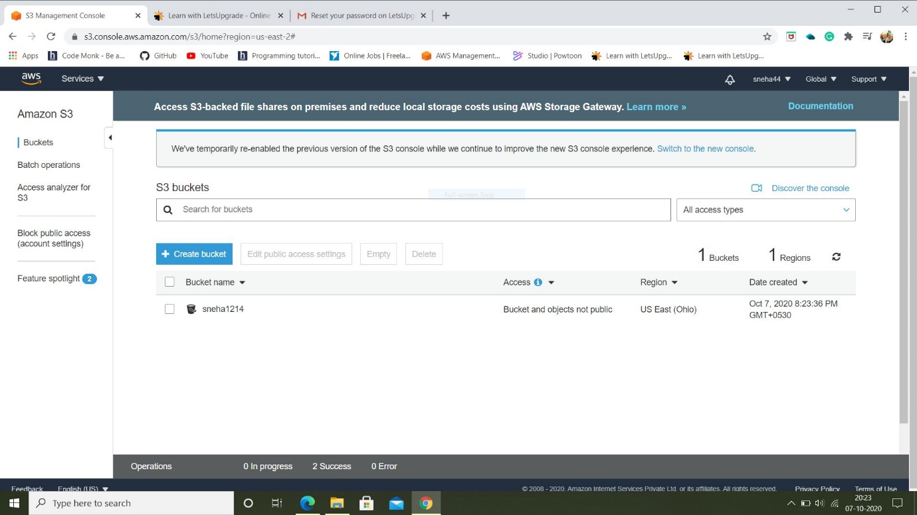

* Uploading a picture:

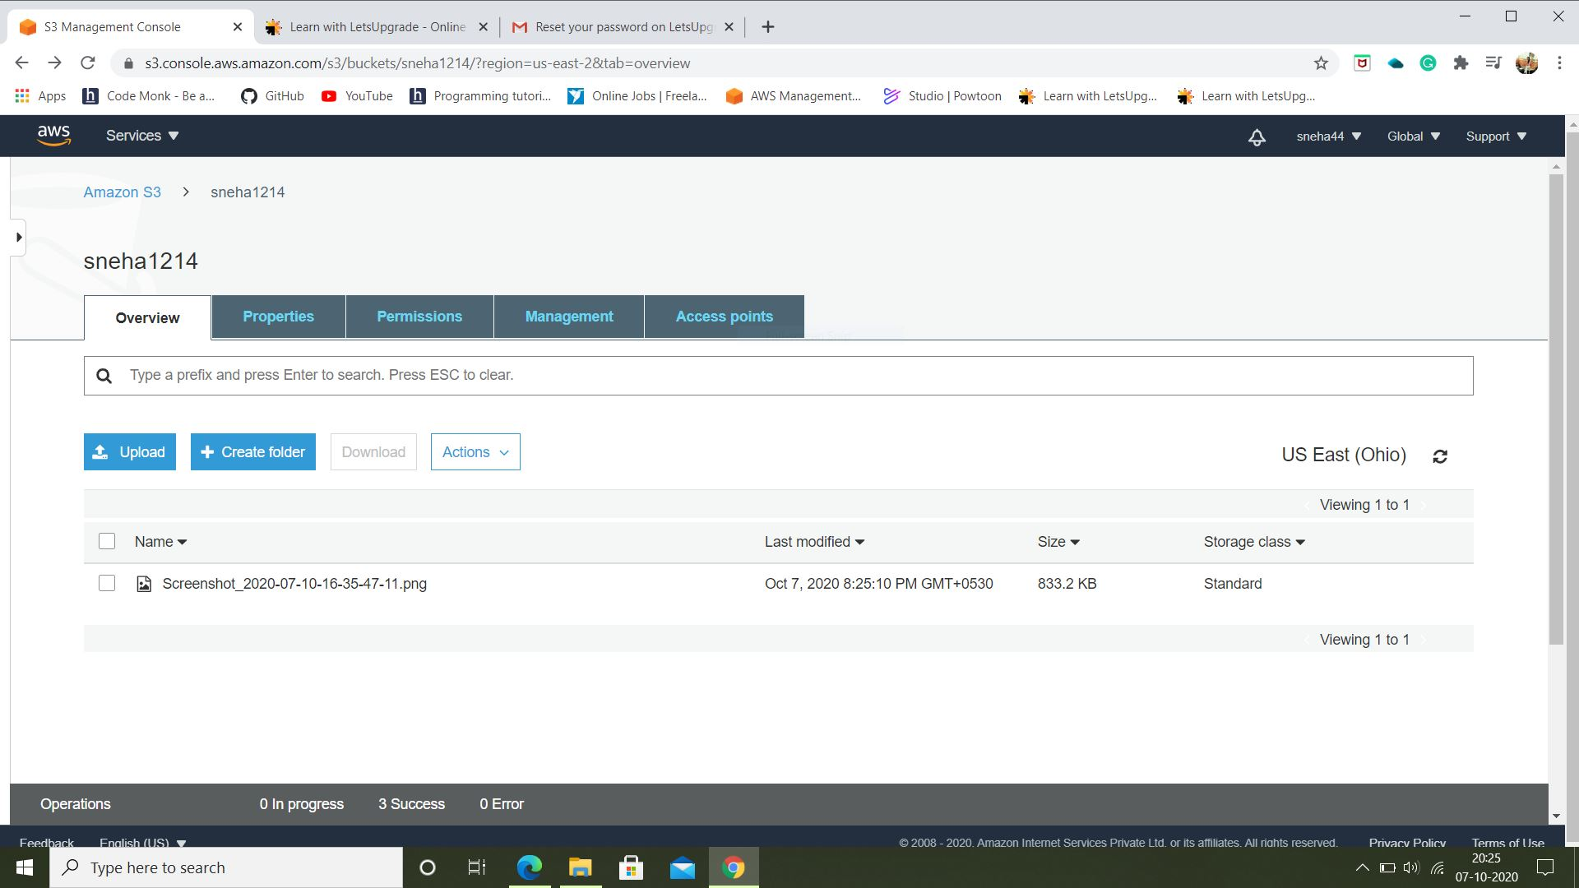

* Access denied

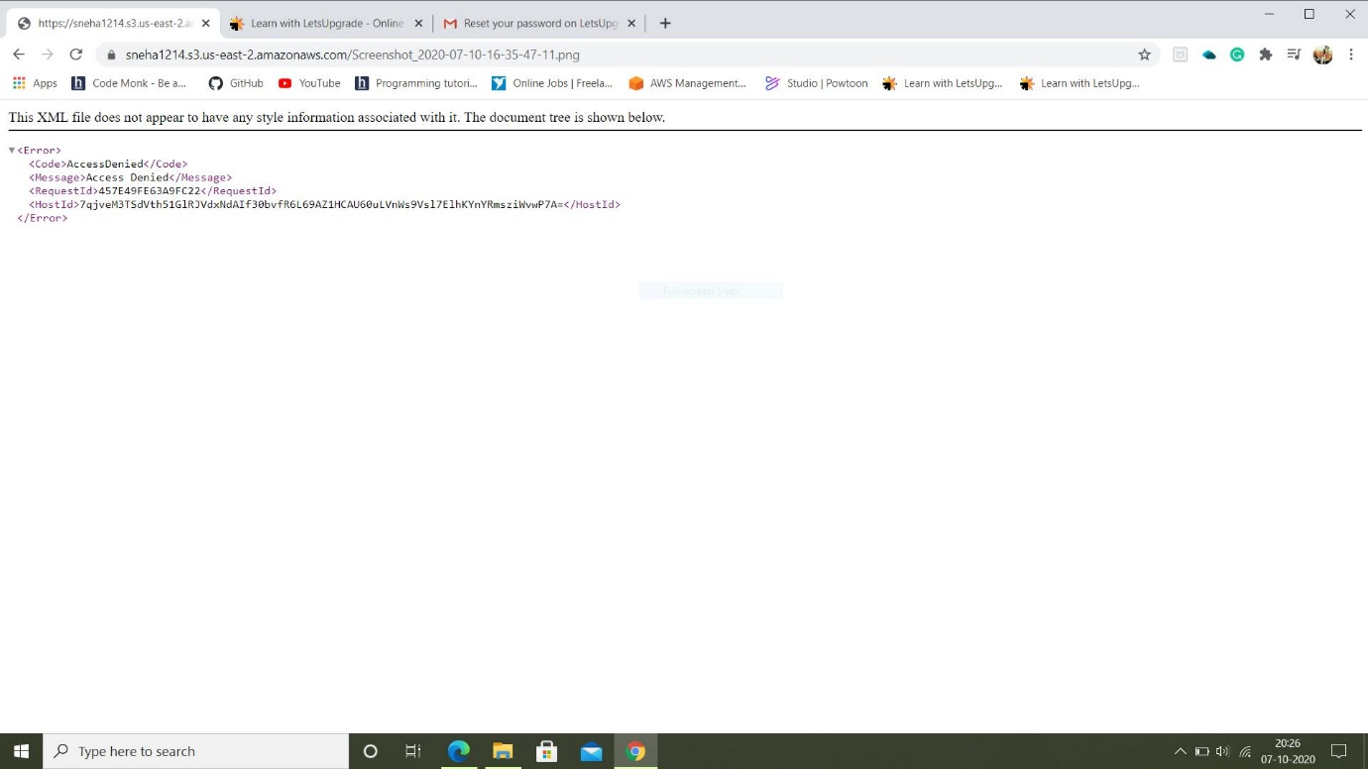

* As access is denied, we have to change the permission by changing the status of Block all public access on to off. Now re-enter the path on browser the image will be viewed.

**For **

* For static web hosting, in properties section we select the Static web hosting where we select ‘use this bucket to host a website’ option.
* Two text files are created index.txt and error.txt entered names of files and then saved.

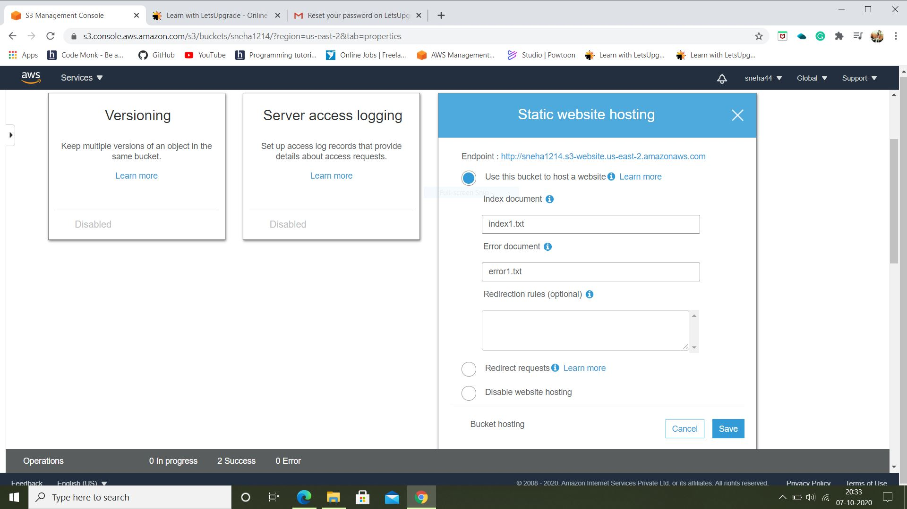

* Those two text files are uploaded in a bucket and are made public.

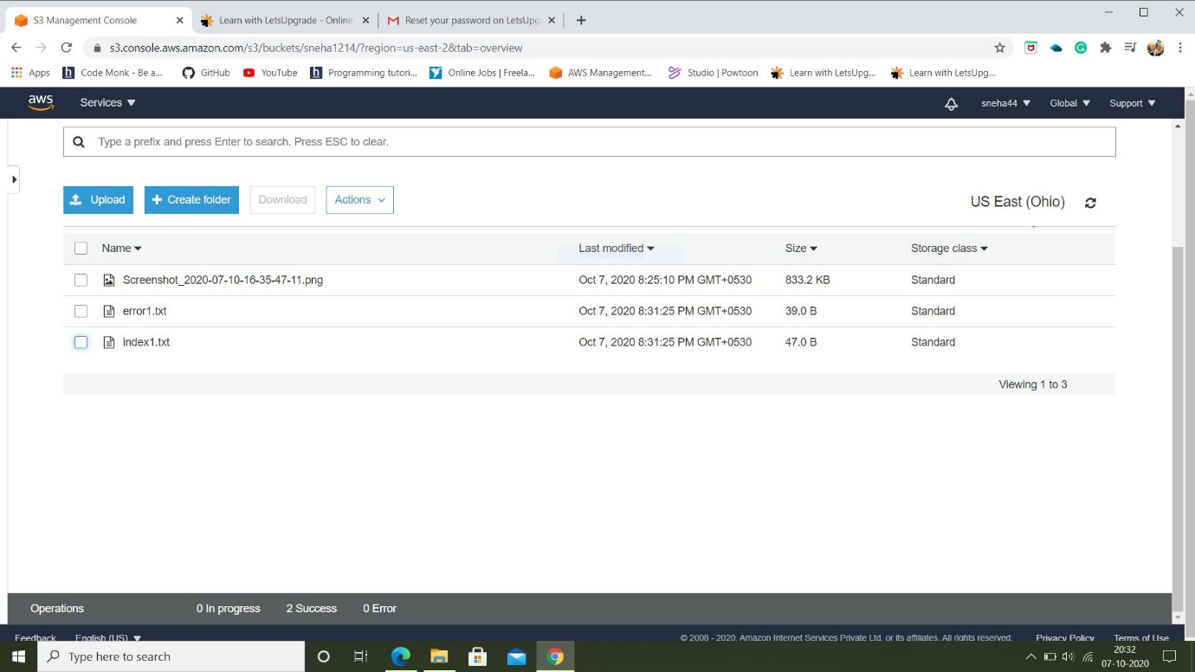

* To check whether files are uploaded successsively, Endpoint address is copied and pasted on browser.
* If address is correct index file text message is displayed else error file text message is displayed.





* Now, for versioning new bucket is created and in properties versioning is enabled.
* A random text file is uploaded in the bucket. After making some changes again the file is uploaded now the file uploaded is the version of the previous uploaded file.

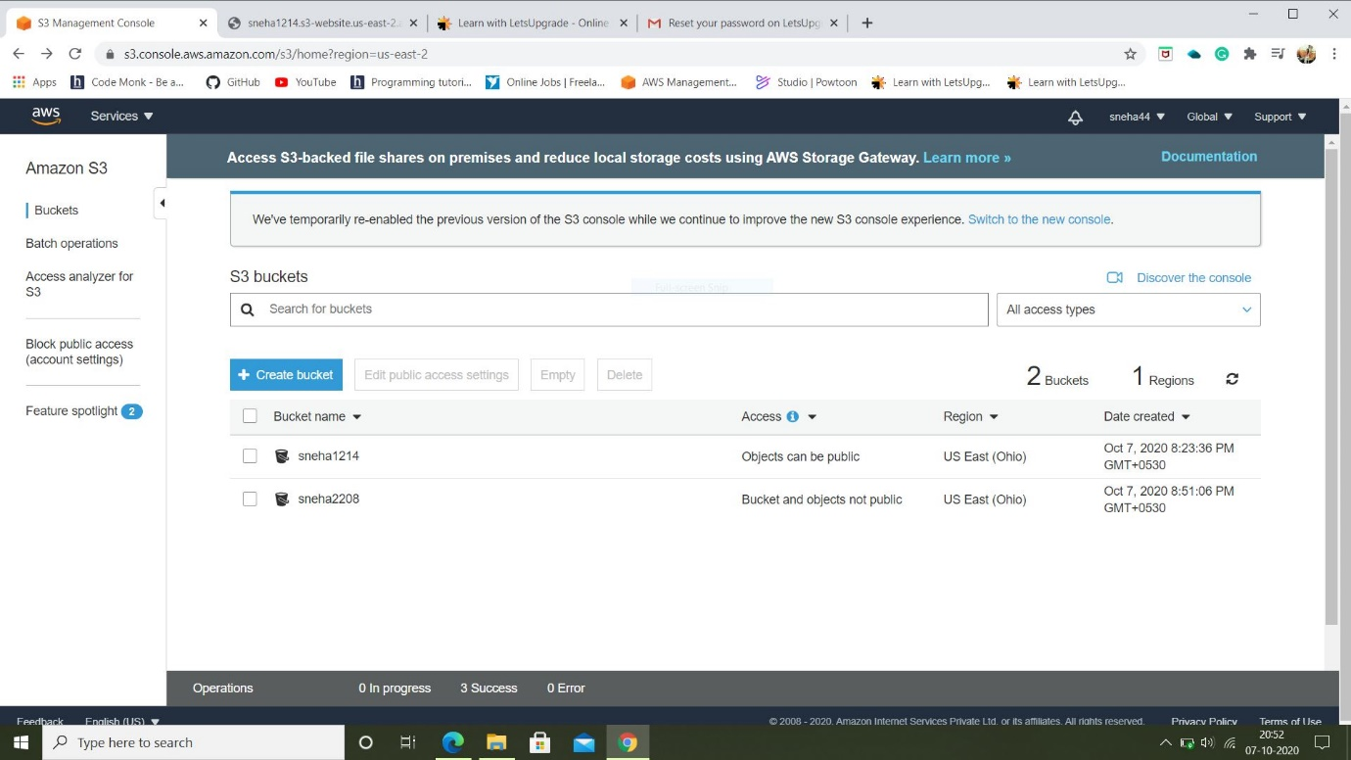

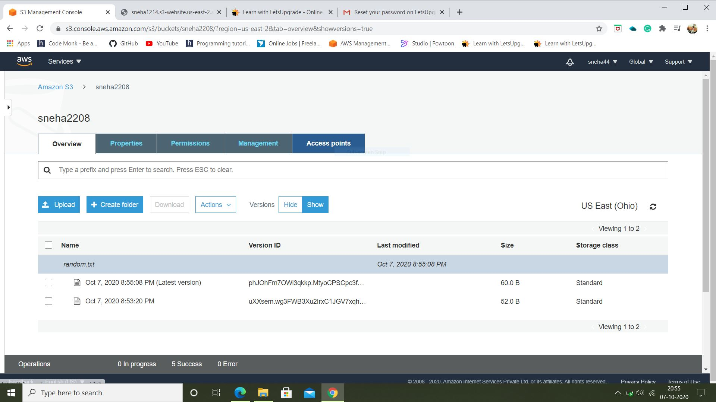

* When the versions are hidden and we delete the main random file uploaded at very beginning and then unhide the versions we see the ‘delete marker’ tag for that file.

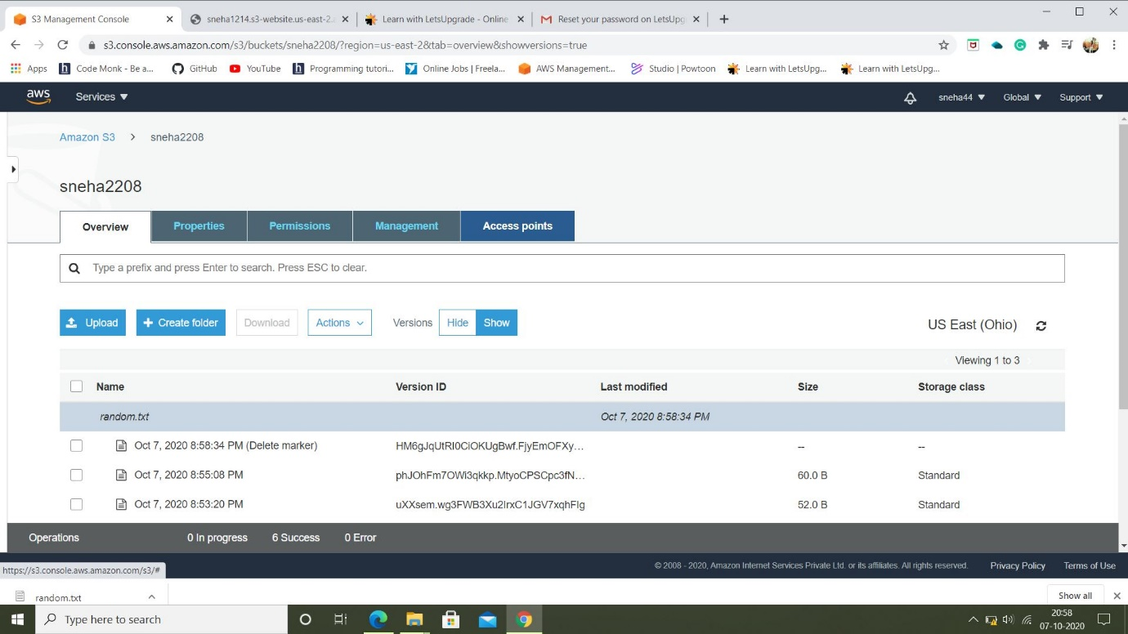

**Thank You!**